**Dynamic Programming Notes**

This file includes my learning notes of Youtube video (<https://youtu.be/oBt53YbR9Kk>). Hats off to the lecturer, Alvin Zablan, for such a great tutorial. The content list is given as

**Contents**

Section I Motivation of having dynamic programming 2

Section II Memoisation 5

Section III Grid Traveller problem 6

Section IV Can-Sum issue 8

Section V How-Sum Problem 10

Section VI Best-Sum Problem 11

Section VII Can-Construct Problem 12

Section VII All-Construct Problem 14

Section VIII Tabulation 15

Section IV Can-Sum Tabulation 16

Section VI Construct Tabulation 18

Section VII Conclusions 20

# Section I Motivation of having dynamic programming

Questions such as calculating the 40th number of the Fibonacci sequence and counting the number of different ways to move through a 6x9 grid can all be categorised into the dynamic programming (DP) cluster. There are two main parts in DP, Memoisation (记忆化) and Tabulation (列表化).

To understand why we need DP, we need to first settle the concept of algorithm complexity. In Java, the recursive algorithm for Fibonacci sequence can be given as Fig. 1.

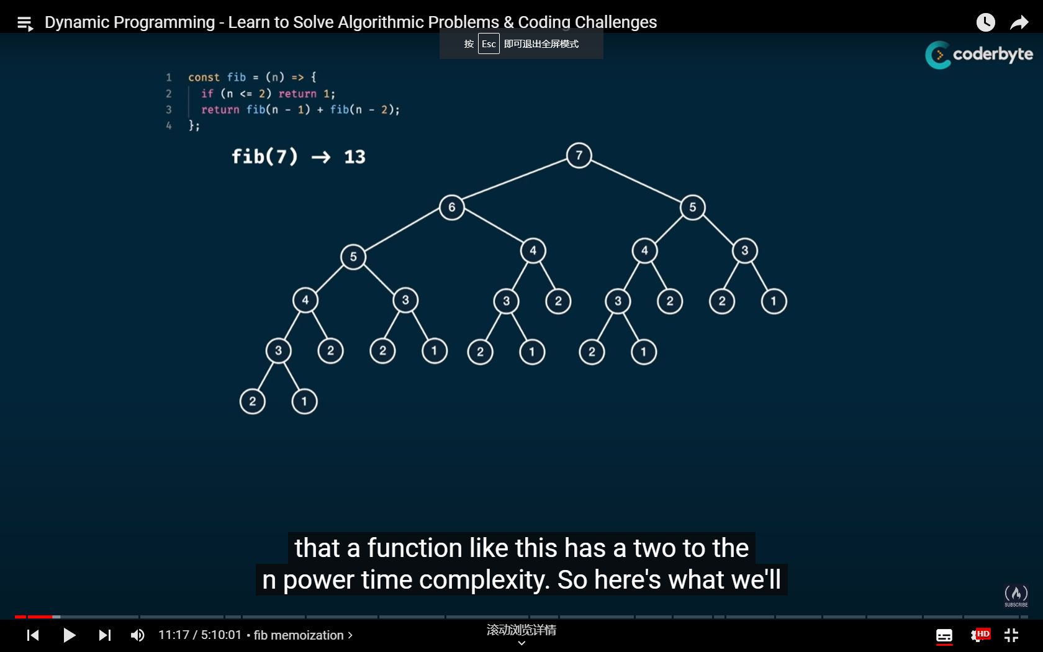

Fig. 1 Illustration recursive algorithm for Fibonacci sequence

However, it seems a bit hard for us to directly consider the complexity of the algorithm. Hence, let’s pick another example in Fig. 2. If we want to obtain the fifth element in the sequence, we need to calculate for 5 times. This indicates that the time complexity of the algorithm is $O(n)$. Similarly, we have that the space complexity is also $O(n)$.

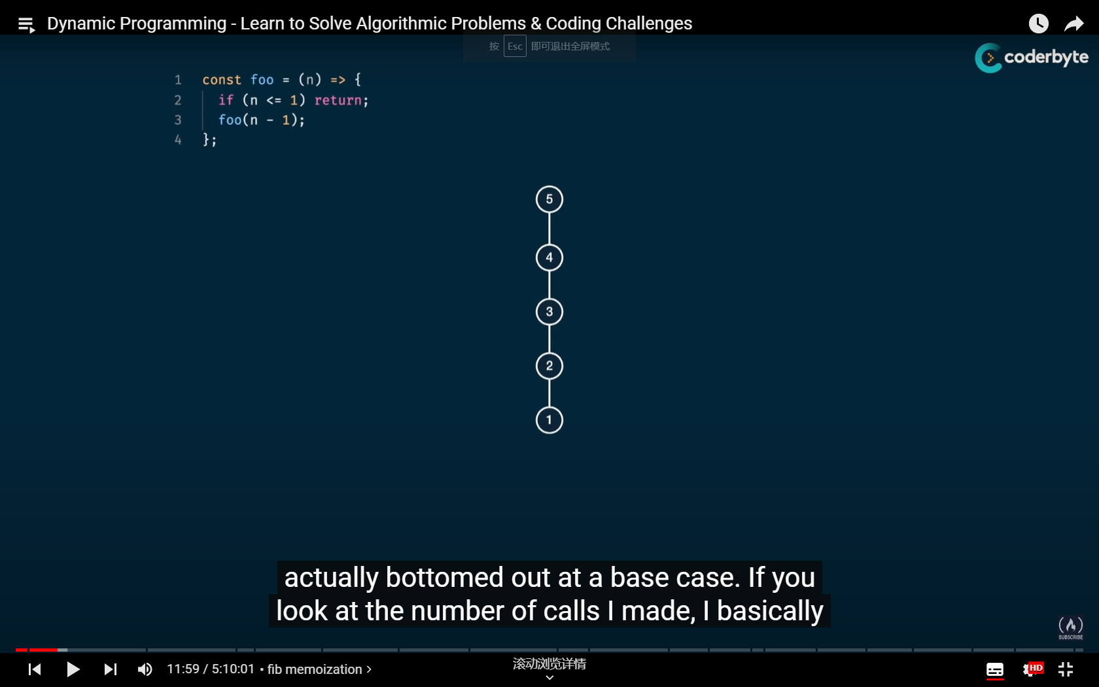

Fig. 2 Illustration of a simple algorithm

If we consider another simple algorithm as shown in Fig. 3, the time complexity is $O(n/2)$, but in computer science, we treat it the same as $O(n)$. The space complexity is also $O(n)$. If you are careful enough, you may have discovered that the algorithm in Fig. 1 is a combination of the one in Fig. 2 and the one in Fig. 3.

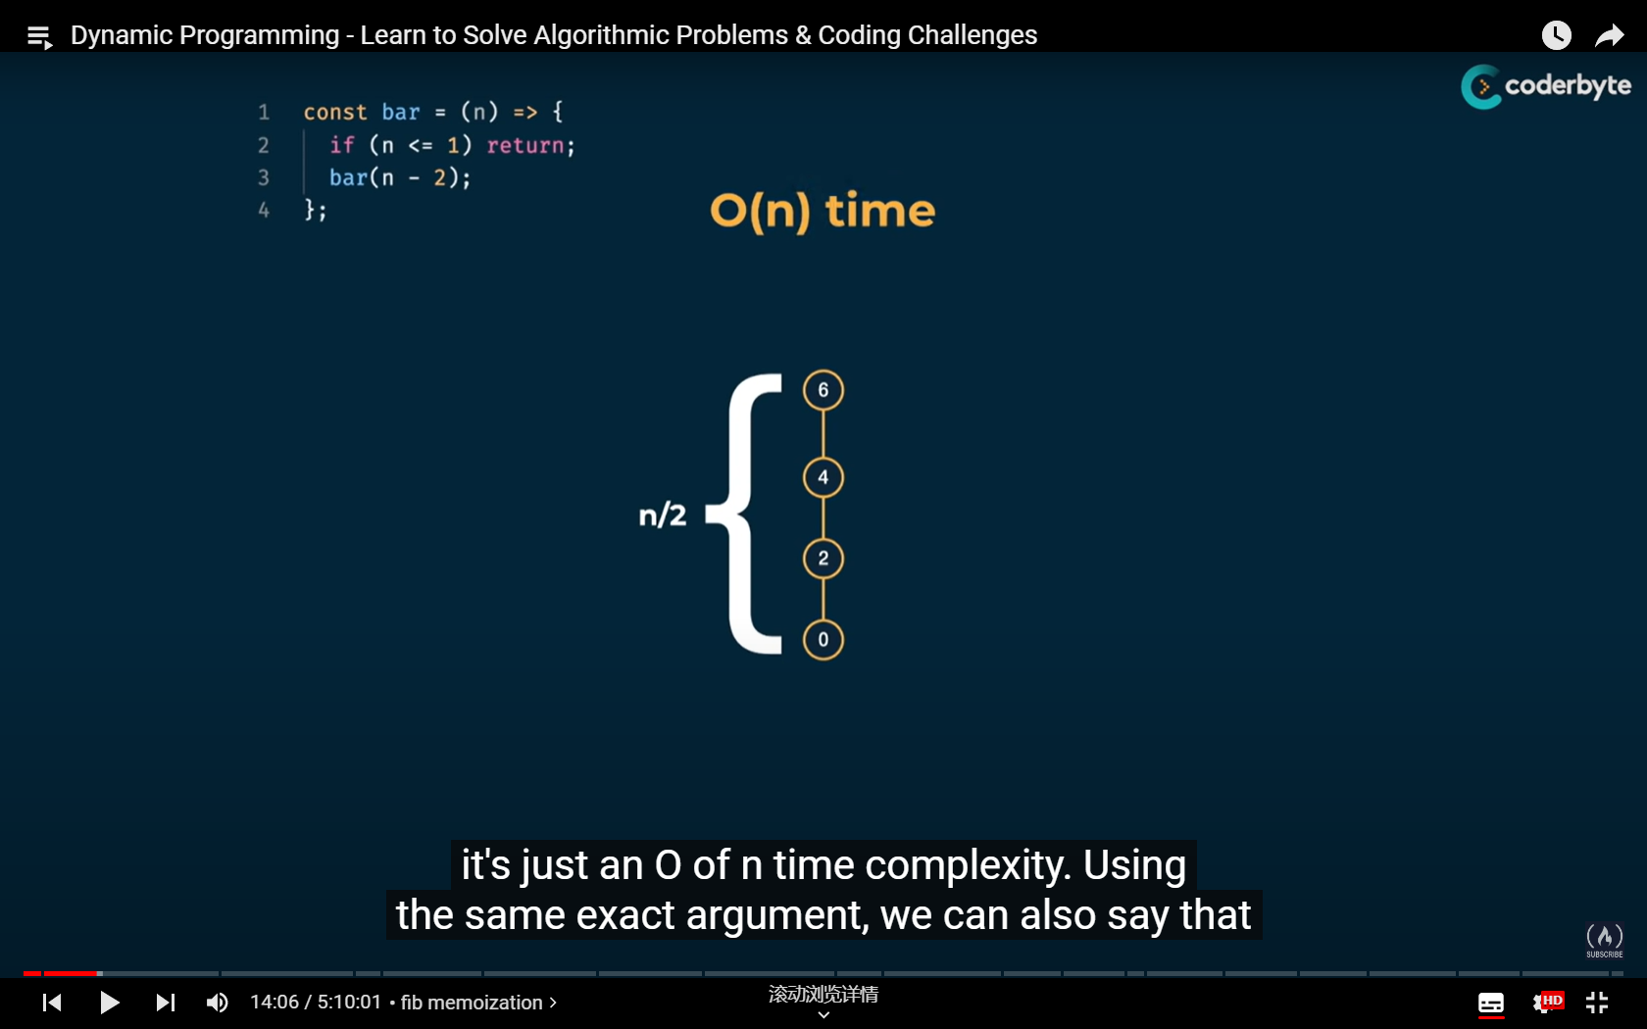

Fig. 3 Another simple algorithm

Consider another “Dib” function as illustrated in Fig. 4. Based on previous discussions, we can see that the time complexity of the Fibonacci algorithm is $O(2^{n}/2)$, which is treated as $O(2^{n})$. Hence, if we run the above problem with the recursive design, then the complexity of the algorithm is also $O(2^{n})$. Meanwhile, the space complexity is $O(n)$ because if we want to calculate the value for $n=5$, every path we need to calculate contains five element at most (5-4-3-2-1).

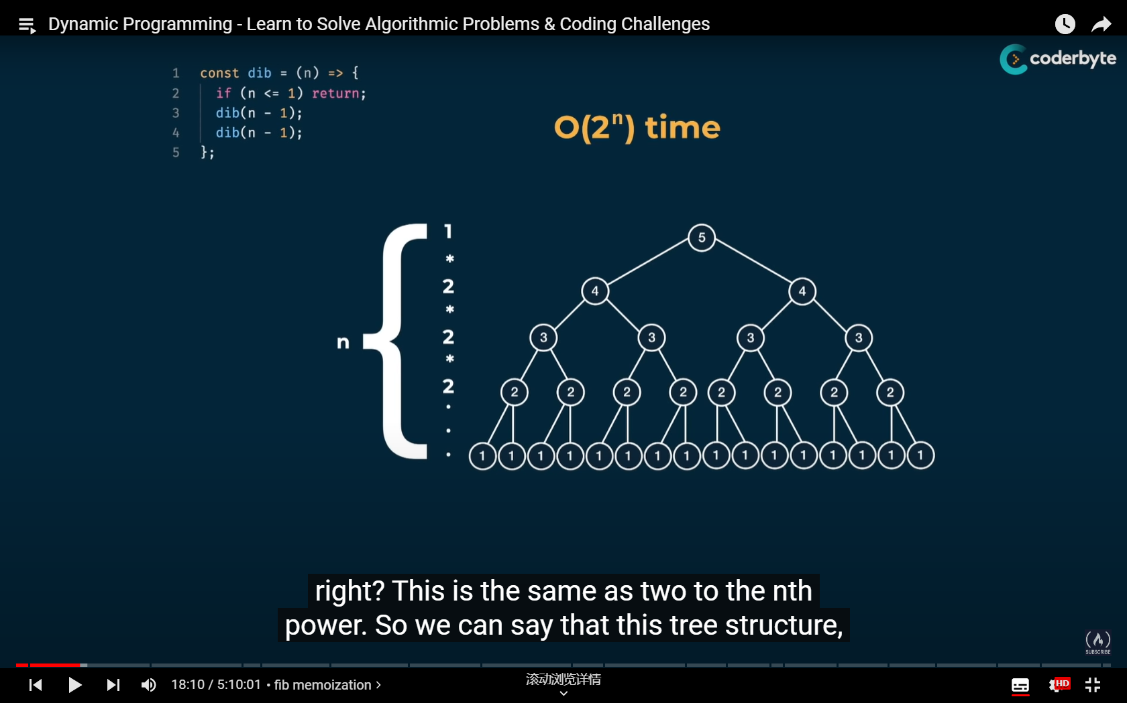

Fig. 4 Complexity of the “Dib” algorithm

Consider another function “Lib” in Fig. 5. Based on our discussion regarding Fig. 4, we know that the time complexity of the algorithm is $O(2^{n/2})$ because the “height” of the algorithm tree is approximately $n/2$. According to the concept, the actual time complexity is $O(2^{n})$.

As discussed, the Fibonacci algorithm can be seen as the combination of “Foo” and “Bar”, which is equivalent to “ $Fib=Foo+Bar$”. In the same sense, we also have “ $Foo=Dib/2$” and “ $Bar=Lib/2$” and the fact that “ $Dib≥Lib$” in the sense of time complexity. Therefore, for the Fibonacci algorithm, we have “ $Lib≤Fib≤Dib$” in the sense of time complexity. Hence, we have that the time complexity of the recursive Fibonacci algorithm is also $O(2^{n})$, which explains why it takes “forever” for us to calculate the 50th element of the Fibonacci sequence by recursive design.

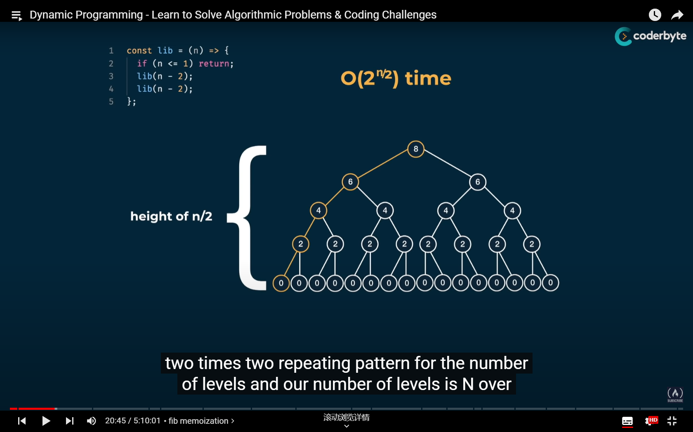

Fig. 5 Complexity of the “Lib” function

Now we have our motivation, to reduce time complexity. To solve this issue, we also need to understand “what’s wrong with the recursive design”. From the algorithm tree in Fig. 6, we can see that a large portion of the calculation is duplicated. Then we have our goal, which is to memorise what we have obtained and trim those unnecessary steps.

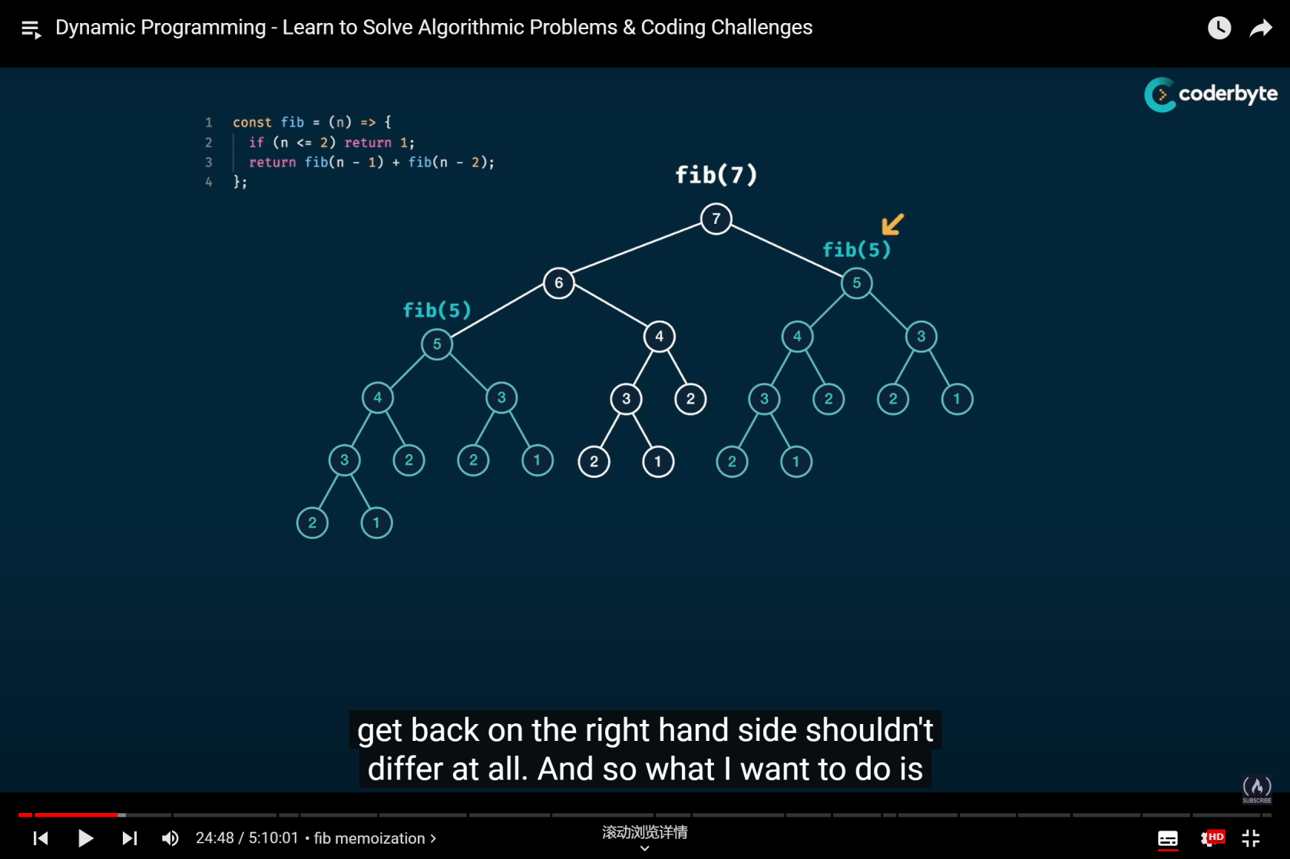

Fig. 6 What’s wrong with the recursive design?

# Section II Memoisation

To reduce complexity, we can introduce one notebook “Memo” into the algorithm so that we can store what we have calculated to avoid duplicate running (see Fig. 7). Now, we can get the values of a Fibonacci sequence in a much faster speed!

Judging by the running speed, we can see that the algorithm design is significantly improved, which means that the algorithm tree of the DP process should be a lot different than the one of the recursive design. In Fig. 8, we present the new algorithm tree of the DP process. You can see that a lot of the unnecessary calculations are omitted, which saves our time. From the figure, we can see that the time complexity and the space complexity of the DP structure are both $O(n)$.

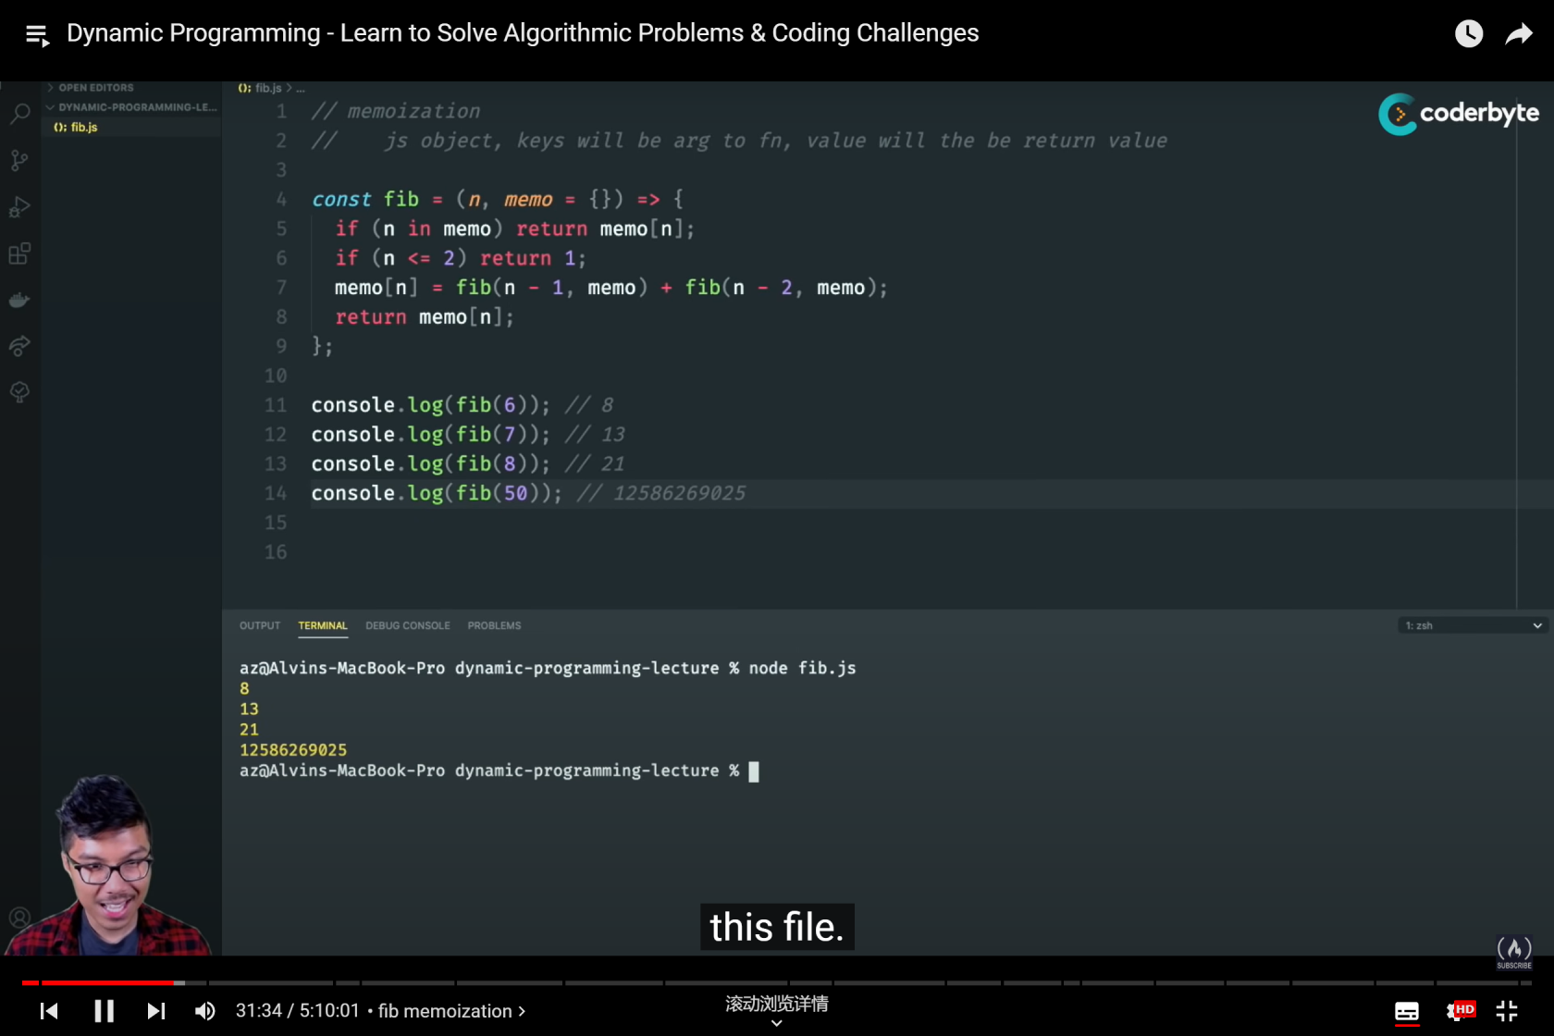

Fig. 8 The updated DP structure

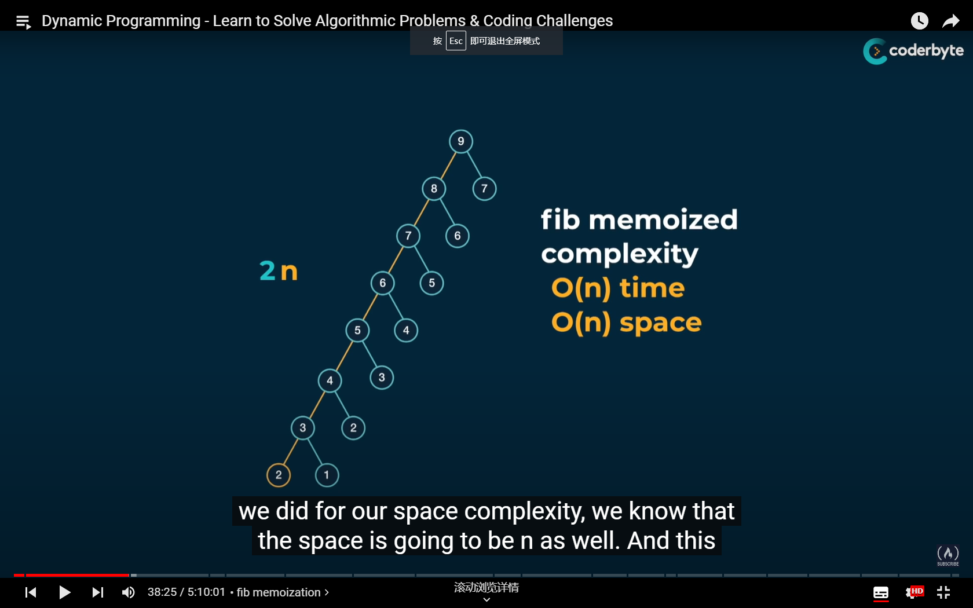

Fig. 9 The new algorithm tree when DP is applied

# Section III Grid Traveller problem

Now we move on to a more complex problem, the grid traveller issue. Suppose you are a traveller on a 2D grid. You begin in the top-left corner and your goal is to travel to the bottom-right corner. You can only move down or right, then in how many ways can you travel to your destination?

Before going deep into this question, let’s first settle some basic scenarios:

1. When at least one of the row-column dimensions is 0, the answer is 0 because we can’t go anywhere.
2. When at least one of the row-column dimensions is 1, the answer is 1 because there’s only one way.

The above two scenarios can be treated as the basic child circumstances that don’t need to be calculated. Similar to the Fibonacci issue, we can see that the time complexity of the recursive design is $O(2^{n+m})$, where $n$ and $m$ are row number and column number, respectively. Meanwhile, judging by the height of the tree, we can see that the space complexity is $O(n+m)$.

Then our main concern is actually the same, to memorise the results we have obtained to avoid duplication. However, the issue is a bit more complex because we have multiple variables that determine the result of one function. Hence, the concept of dictionary is introduced. By creating a dictionary, we can have a one-on-one match between a key (which includes the variables we have in a string/integer format) and the function value (the number of possible paths from the beginning to the destination).

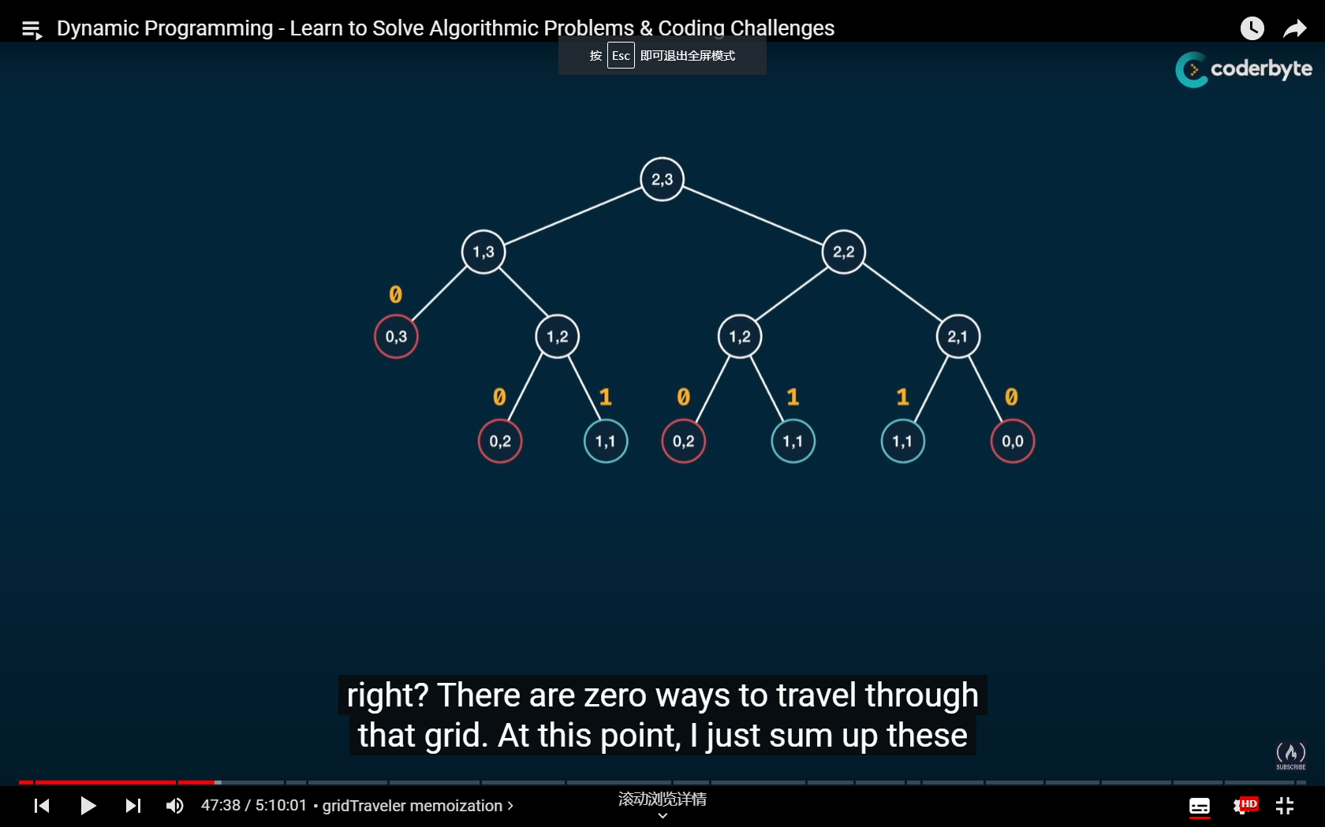

Fig. 10 The algorithm tree when row=2, column=3

By the time we have a set of input (row and column numbers), we can start the irritation by asking if the keys we are looking for already has a corresponding answer. If yes, then we just use the answer directly. If not, then we calculate the current circumstance by adding up the result of two child circumstances, where we have one less row, and where we have one less column, which further leads to Fig. 11.

In the sense of time complexity, because there will roughly be $m*n$ kinds of situation in total (actually a bit less because we stop calculating when row or column is 1). Hence, we made an improvement from $O(2^{n+m})$ to $O(n+m)$ in time complexity, while the space complexity stays the same.

To sum up, we need to follow a two-step procedure to have a good DP structure.

Step 1: Visualise the problem as a tree and make it work in a recursive design.

Step 2: Introduce a memo object (or a notebook as you may want) to store the answers you have calculated to make your algorithm efficient. Also, always have basic cases that directly returns values.

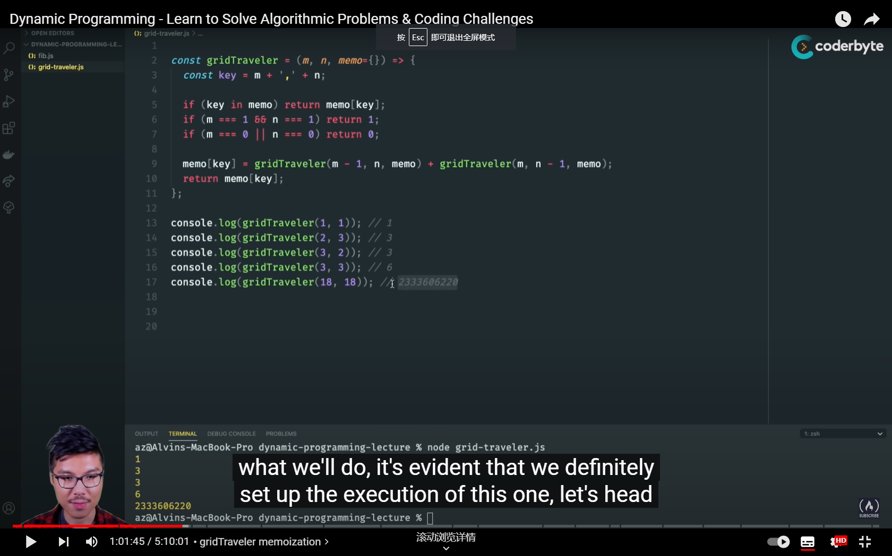

Fig. 11 Algorithm design of the grid traveller issue

# Section IV Can-Sum issue

Now we consider a new problem, the Can-Sum issue. The question is, suppose we have a target number $m$ and a possible selection array $S$, which includes $n$ nonnegative independent variables. If we assume that we can use every independent element in $S$ for nonnegative number of times. Then our goal is to develop an algorithm that can help us determine if there is a combination of arbitrary elements from $S$ that can help us obtain the target number $m$.

For example, if we have $m=7$, then we should obtain a Boolean answer “True” when $S=[3,4]$ because we have $m=3+4$. Accordingly, when $S=[2, 4]$, we will return “False” because we will run out of choices.

Again, we start with the recursive design, which means that there will be no “memory-based” structure that records the circumstances we have calculated. While we are trying to determine the time complexity, we need to consider the worst-case scenario. As usual, we will use the algorithm tree for illustration. First, we need to know about the height of the tree. Suppose we have element “1” in $S$, then the longest path we have contains $m$ nodes in total.

For each node, we will have $n$ different choices to check. Hence, each node would split into $n$ different sub-nodes in the next level. Therefore, the time complexity of the algorithm can be given as $O(n^{m})$. Because the height of the tree is m nodes, then the space complexity is $O(m)$.

**Remark 1**. Regarding the worst-case scenario that we have element “1” in $S$, the longest path should contain $m+1$ nodes because the iteration won’t stop until we hit “0” or something negative. However, if there is a “1” in $S$, then every nonnegative element should result in “True”. Hence, we have that the height of the algorithm tree is at most m nodes high.

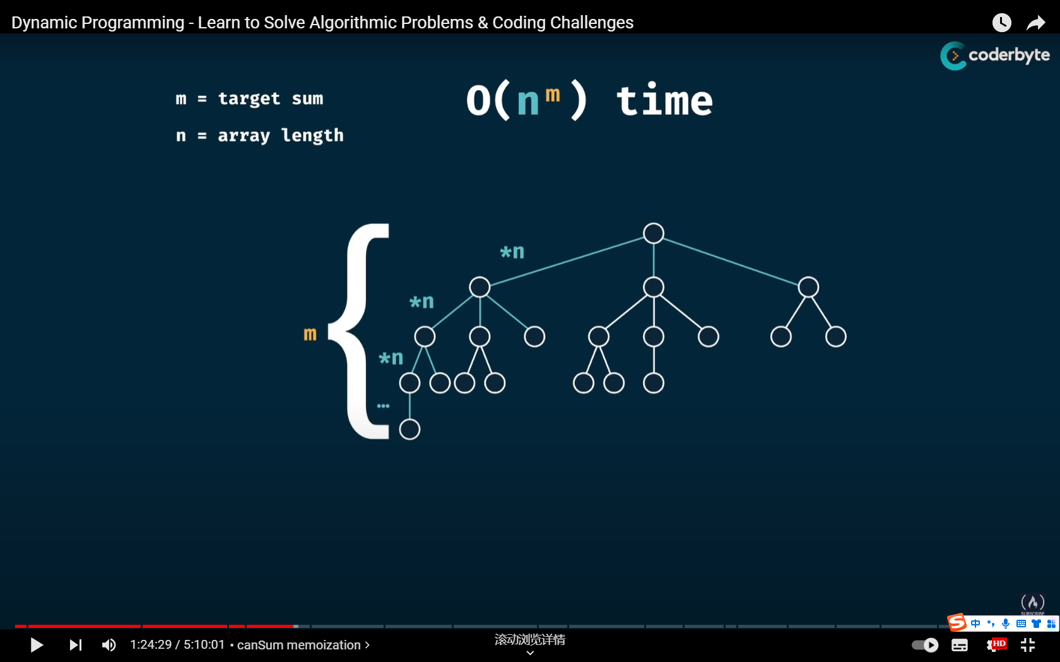

Fig. 12 Recursive design of Can-Sum issue

Just as the video mentioned, the recursive algorithm for case $m=300$, $S=[7,14]$ will take a long time to finish. Then it is time for us to include the memory-based structure, our notebook (or I would usually call it the result dictionary).

Accordingly, we have the DP-based design in Fig. 13. Regarding the time complexity of the program, because the recursive calculation will not stop until we hit 0, then there should be at most $m$ target numbers we need to check. For each possible target number, the result is also determined by its $n$ child scenarios (in specific, the results of $m-S\left(1\right)$, $m-S\left(2\right)$,…, $m-S\left(n\right)$). Hence, there should be about $n*m$ possible scenarios we need to check. Then the time complexity should be $O(n*m)$. The space complexity remains to be $O(m)$ because we only need to store the result of $m$ scenarios at one time to ensure we can have the correct result.

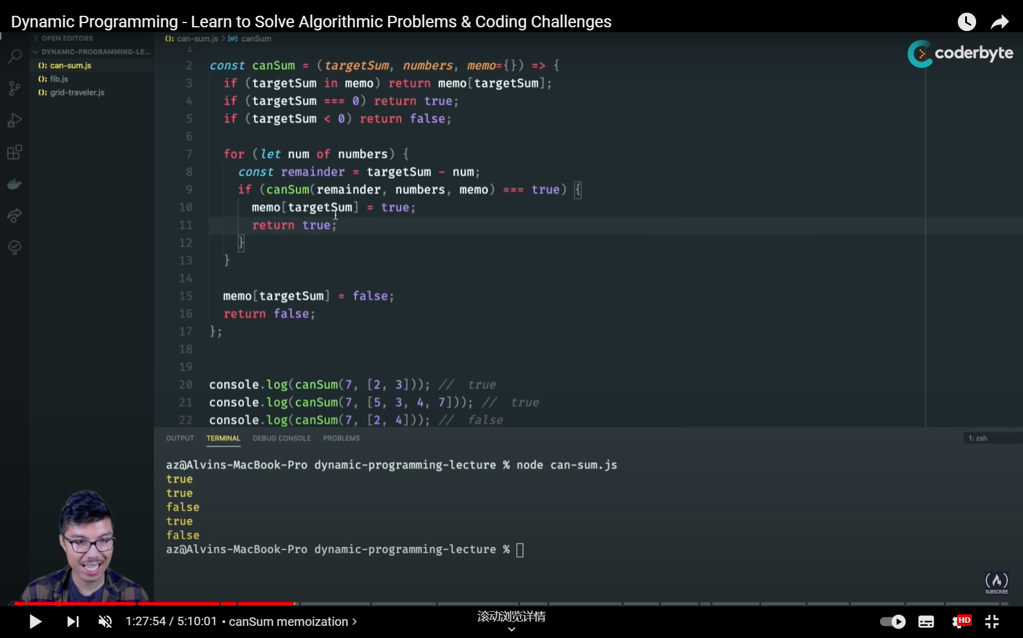

Fig. 13 The DP-based algorithm design for Can-Sum

# Section V How-Sum Problem

Then we move on to the next problem, the How-Sum problem. This problem is still based on a target number $m$ and a possible selection array $S$. If we can obtain the target number with the given array, we need to return an arbitrary list that contains a feasible combination. Otherwise, we return None/False.

The overall logic stays the same, but we need to alter what’s returned from the basic cases. As mentioned, we have the following three basic cases:

1. When the target number is 0, the current combination works, meaning that we need to record the choices we made. Hence, we return an empty list “[]” to the above layer to start recording.
2. When the target number is negative, the current combination is not valid. Hence, we return “None/False” (remember to distinguish the difference between “None” and “[]”) to the above layer.
3. When the target number is a valid key in the dictionary (memo) we have, then return the recorded corresponding value to the above layer.

Then we have the new circumstances again. Similarly, we will use a For loop to examine the all the possible circumstances. In each subbranch, suppose the element we choose from $S$ is $S(1)$, then we need to use the designed function to obtain the result for $m-S(1)$. If the returned value is an array, then we break the loop and add the current choice $S(1)$ to the array and return to the previous layer. Otherwise, we will wait until we run out of options and return “None/False” to indicate that this node cannot return a valid answer.

According to Fig. 12, there will be at most $n^{m}$ nodes in total. However, we may need to copy the array returned by the previous layer to act as the returned value, and the array can be at most $m$-unit long (suppose that we have an array with ones). Hence, the time complexity is $O(n^{m}m)$.

According to the algorithm tree, each sub-path contains at most $(m+1)$ nodes. If we start returning an empty array from the $(m+1)$ th node to start recording, then the array will contain 1 element when we are at the $m$ th node. If we move up another layer, the array will contain 2 elements at the $m-1$ th node. Following this order, the array contains $m$ elements when we are at the first node. Hence, the space complexity is $O(m)$.

By using the dictionary function to record the calculated scenarios, we can reduce the time complexity to $O(nm^{2})$ because there could be at most $m$ target numbers, each target number has at most $n$ sub-scenarios and in each scenario, we need to copy an array that is at most $m$-unit long.

Meanwhile, because there will be at most $m$ target numbers and the recorded returned result of each scenario is at most $m$-unit long, the space complexity is $O(m^{2})$.

# Section VI Best-Sum Problem

Then we upgrade the problem into Best-Sum, and the final goal is to obtain the shortest combination that can help us obtain the target number. The basic algorithm design stays the same, while we need to add a comparison-based structure to help us obtain the optimal answer. Accordingly, we keep the following basic scenarios from the previous section:

1. When the target number is 0, the current combination works, meaning that we need to record the choices we made. Hence, we return an empty list “[]” to the above layer to start recording.
2. When the target number is negative, the current combination is not valid. Hence, we return “None/False” (remember to distinguish the difference between “None” and “[]”) to the above layer.
3. When the target number is a valid key in the dictionary (memo) we have, then return the recorded corresponding value to the above layer.

While we are looping through all the possible choices in the possible selection array $S$, we won’t break the loop until all choices have been examined. If the returned value from one of the sub-scenarios is not “None/False”, then we choose:

1. Save the returned value as the current optimal choice when we don’t have a feasible answer before.
2. If we had an optimal choice in our hand, then compare the length of the two choices and only save the shorter one.

The time complexity remains to be $O(n^{m}m)$ for the recursive design while the space complexity changes to $O(m^{2})$ because we have at most $m$ scenarios where we need to save the optimal combination and the combination is at most $m$-unit long.

Regarding the DP-based design, both the time complexity and the space complexity are the same to the ones in How-Sum problem.

# Section VII Can-Construct Problem

Now we move on to the Can-Construct problem. There are two inputs for this question, a target word “target” and a “wordbank” array that contains all possible choices for us to construct “target”. Our desired output is a Boolean variable, whether “True” or “False”. This question is quite similar to the Can-Sum problem because it is a **Decision Problem**.

Different from the Can-Sum problem, we are now facing an issue correlated with strings instead of integers now. Hence, we need to clarify the conditions that determines if one substring from the wordBank is a valid candidate that can form the “target”.

Suppose we have the “target” as “Potato”, and the “wordBank” is [“Poto”, “ta”, “tato”, “P”]. Then we can see that “Poto” is not a valid candidate. Then some might say that the second substring “ta” is a valid candidate because we have “ta” in “Potato”. However, it’s actually not. If we did treat “ta” as a valid candidate, then we certainly need to get rid of it to make a new “target” for the next round of checking. Then the new “target” would be “Poto” and it perfectly matches the first element in “wordBank”, which indicates that we would have “True” as our final result.

However, according to the information we have, the answer should be “False” because we cannot arbitrarily break down the basic elements in “wordBank” to construct the “target”. Hence, while checking if a substring is a valid candidate, we need to see if the substring can perfectly match **a part of the “target” from index “0”**. Then the basic structure of the Can-Construct problem is given as

1. If “target” is an empty string, then return “True”.
2. Else if “wordBank” is an empty list, return “False”.
3. Else if the result of the current “target” already exists in the dictionary, return the stored values.
4. Else, we start to loop from all the possible choices in “wordBank” to see if we can have a perfect zero-indexed match (the initial letter of the current choice should be the same as the one of “target”). If so, we record the result, update the target word and see if the new target word can be constructed. If no match is found after completing the loop, we record it in the dictionary and return False.

Now let’s consider the complexity of the algorithm. First, we start with the recursive (memory-less) design. Suppose the “target” is a string with $m$ letters, then the algorithm tree will be at most $m$-level deep (in the worst-case scenario where we only take away one letter each level). If the “wordBank” contains $n$ feasible choices, then there will be at most $n$ subbranches in each level. Hence, there are $n^{m}$ nodes in total. While we are at each node, we also need to loop from the beginning of the current target to see if our choice is a match and then cut our target shorter for the next iteration. This means that we will have at most $m$ calculations to make on the target string. Therefore, the time complexity of the recursive design should be $O(n^{m}m)$. Accordingly, the space complexity should be $O(m^{2})$ because we only need to store the results of $m$ different scenarios at one time step (again, consider the longest path we can have) and the longest content to save has the length of $m$ units (see Fig. 14).

For the DP-based structure, we shrink the time complexity to $O(nm^{2})$ because there will be at most $m$ different keys in the dictionary. For example, if we have “Potato” as the target, then there will be at most 6 scenarios: “Potato”, “otato”, “tato”, “ato”, “to” and “o”. For each key, we need to check through all the feasible selections in “wordBank” to see if there’s a result. And in each sub-scenario, we will loop from the beginning of the target to the end. And the space complexity remains to be $O(m^{2})$.

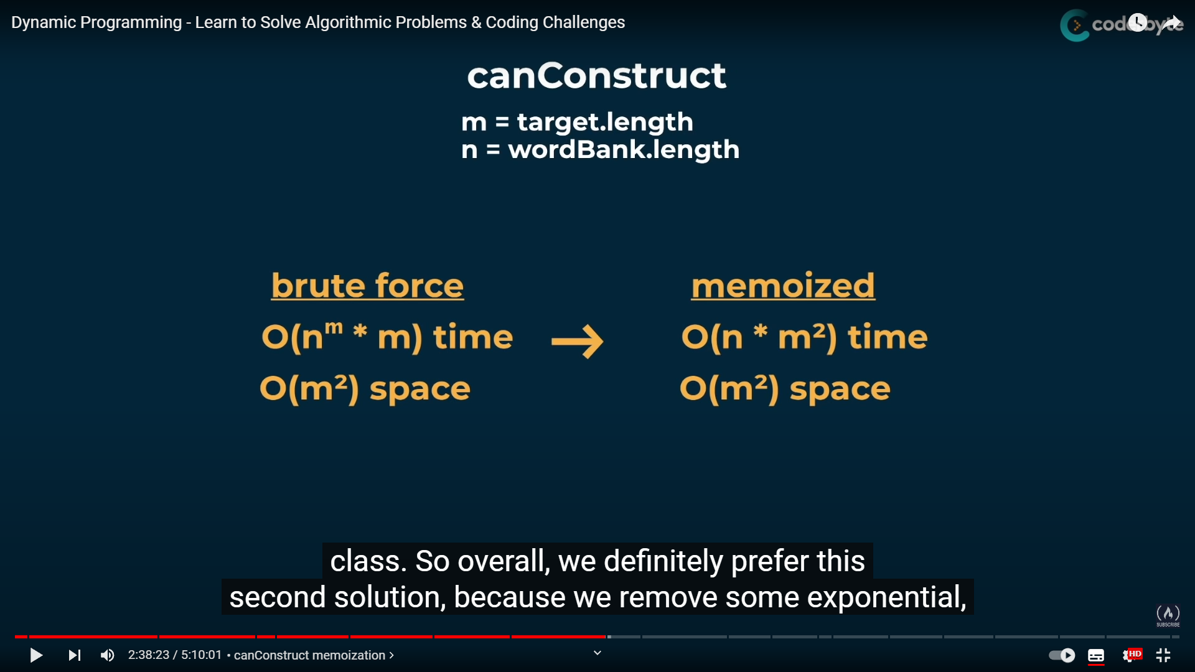

Fig. 14 Can-Construct Problem

If we want to solve “Sum-Construct” problem, which is to calculate the total amount of ways to obtain the target string, we will use the same structure. The complexity analysis stays the same.

# Section VII All-Construct Problem

Then we pick a more complex scenario, where we need to collect all the possible choices in an array. In specific, we need to return an array of array(s). For example, if we have “target=Potato” and “wordBank=[“Po”, “to”, “ta”, “tato”]”, then we need to return “[[“Po”, “ta”, “to”]; [“Po”, “tato”]]”. Besides, there are some special scenarios:

1. If “target=[]”, then we return “[[]]”, which is a 2-dimensional array. (You can also imagine this as a $1×0$ matrix)
2. If the “wordBank” cannot help us get “target”, then we return “[]”, which is an empty array.

Apart from the above two basic scenarios, we also need to settle the case where we need to specific how can we make a new target word from the “wordBank”. Firstly, we need to loop through all the elements in “wordBank” to see if the current target word starts with anyone of them.

If we have an element “A” that satisfies the above condition, we need to dig deeper to see if the rest of the strings can be constructed by the “wordBank”. If yes, we need to add “A” in the beginning of every returned answer and hardcopy the list as the corresponding value in the dictionary. Besides, we also need to be ready for the case where we need to fill some new answers into one existed key in the dictionary, which means we need to fill in all the sub-lists after the original value (of lists).

# Section VIII Tabulation

Memoisation is not the only way to carry out the DP-based process. And now, let’s move on to “Tabulation”. Basically, “Tabulation” is a method that projects our issue into the shape of a list (or an array). Take the Fibonacci question mentioned in Section I as an example, if we want to obtain the $n$ th number in the Fibonacci sequence, then we have $n+1$ scenarios to consider (0, 1, 2, … n).

Instead of saving the value of each element in a dictionary, we can instead use a list/an array, which is illustrated in the figure below:

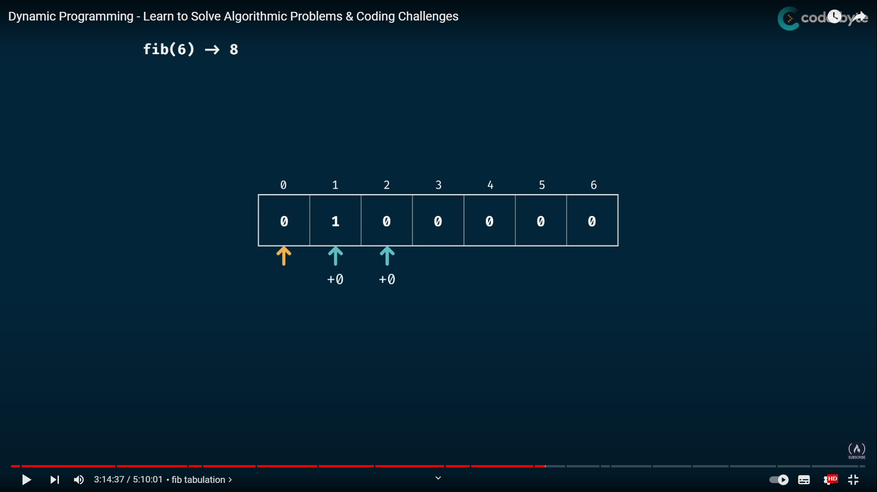

Fig. 15 The tabulation approach for Fibonacci sequence

After settling the basic scenarios, we can then use a For loop to calculate the remaining values. Regarding the time complexity and space complexity, they remain to be $O(n)$ simultaneously, which is quite straight forward as shown in Fig. 15.

For the Grid Traveller issue, the concept of using tabulation is more straightforward. Different from the Video, I think constructing an empty list with the dimension of $row_{num}×{col}_{num}$ is more than enough because the cases where we have 0 rows or 0 columns should have a return value of “0”.

Then the element $List[i][j]$ we construct should represent the result when we $(i+1)$ rows and the $(j+1)$ columns. When either $i$ or $j$ is 0, the returned value is 1. Otherwise, we have

$$List\left[i\right]\left[j\right]=List\left[i-1\right]\left[j\right]+List[i][j-1]$$

Accordingly, the basic steps for the Tabulation approach are

1. Visualise the problem as a table.
2. Initialise the list with a proper size according to the input/basic parameters.
3. Settle the basic cases (elements in the list)
4. Find a proper logic to iterate through the table and calculate non-basic elements with currently available elements

# Section IV Can-Sum Tabulation

In terms of the Can-Sum problem, it is easy to understand that we need to construct an $(m+1)$-dimensional list, where $m$ is the value of the target number. Because the expected answer is True/False, we can initialise all the elements as “False”.

Personally, I think the biggest difference between the Memoisation-based approach and the Tabulation-based approach is the way of thinking. In Memoisation-based approach, we usually follow the forward-thinking pattern. Take the Can-Sum scenario for an example, if a target number $m$ is given, then whether $m$ can be formed by numbers $n=[n_{1}, n_{2}]$ is determined by the OR operation of the following two results:

1. Can $m-n_{1}$ be constructed by $n$?
2. Can $m-n_{2}$ be constructed by $n$?

We will keep iterating until the new target number is 0 or negative, which are our basic cases. The basic cases will have a solid “True” or “False” to return. Then the algorithm will bring these solid answers up to help determine our final answer.

But the Tabulation-based approach is a lot different and works in a reverse-thinking fashion. In Tabulation, we work from 0 and see what we can obtain with $n=[n_{1}, n_{2}]$. In other words, we first settle that the answer is “True” when $m=n_{1}$ or $m=n_{2}$. Suppose we have $n_{1}<n_{2}$, we then jump to $m=n_{1}$ and turn the result of $m=n_{1}+n_{1}$ and $m=n_{1}+n_{2}$ to be “True”. Afterwards, we move on to $m=n_{2}$ and turn the result of $m=n_{2}+n_{1}$ and $m=n_{2}+n_{2}$ to be “True”, etc. This process can be illustrated as the following figure:

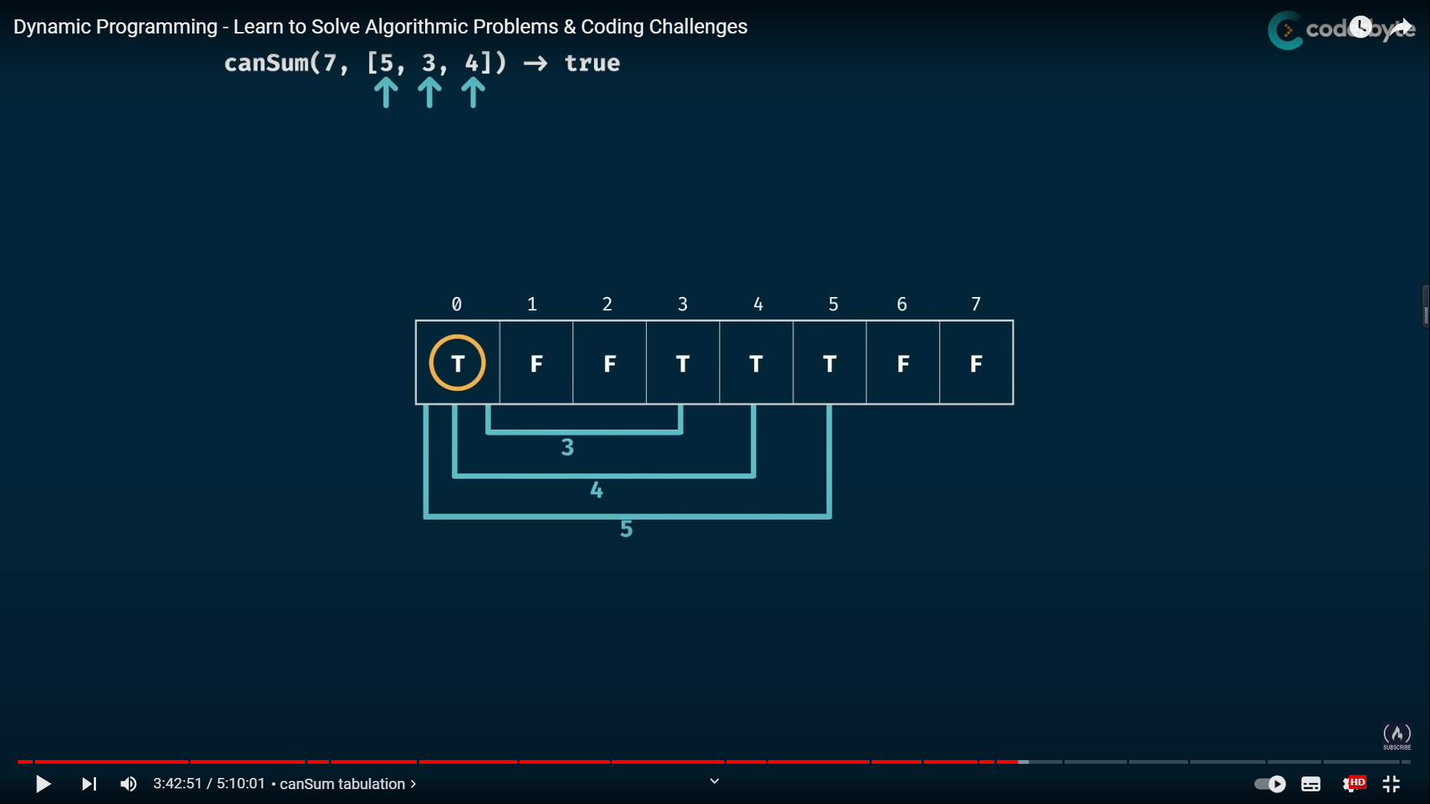

Fig. 16 The Tabulation-based process of Can-Sum problem

Then we need to settle the basic scenario. From the previous discussion, it is clear that 0 is the basic scenario. Hence, we always have $List\left[0\right]=True$. And the rest is we start with $List\left[0\right]$ and loop through all the elements in the list. Because the length of the list is $(m+1)$, the space complexity of the above Tabulation-based design is $O(m)$. For each element, we need to loop through all elements ( $n$ in total) in “numbers”. Hence, the time complexity is $O(mn)$. While the space complexity is $O(m)$.

**Section V How-Sum Tabulation and Best-Sum Tabulation**

Next, we swing back to the How-Sum problem. As required, we need to return any feasible combination that can let us get the target number, meaning that the returned values should be a list.

Then we need to settle the basic scenario, which is when the target is 0, the returned value should be an empty list “[]”. As always, we need to loop through all the elements in numbers. Instead of only giving True or False, we now need to include some contents in the array. For example, when we start with $m=0$ and $n_{1}=5$ as the following figure, we need to include $n_{1}$ into the array to have $[5]$ for element $List[5]$. Similarly, when we start with $m=3$ and $n_{1}=5$, we need to have $List\left[8\right]=[3, 5]$.

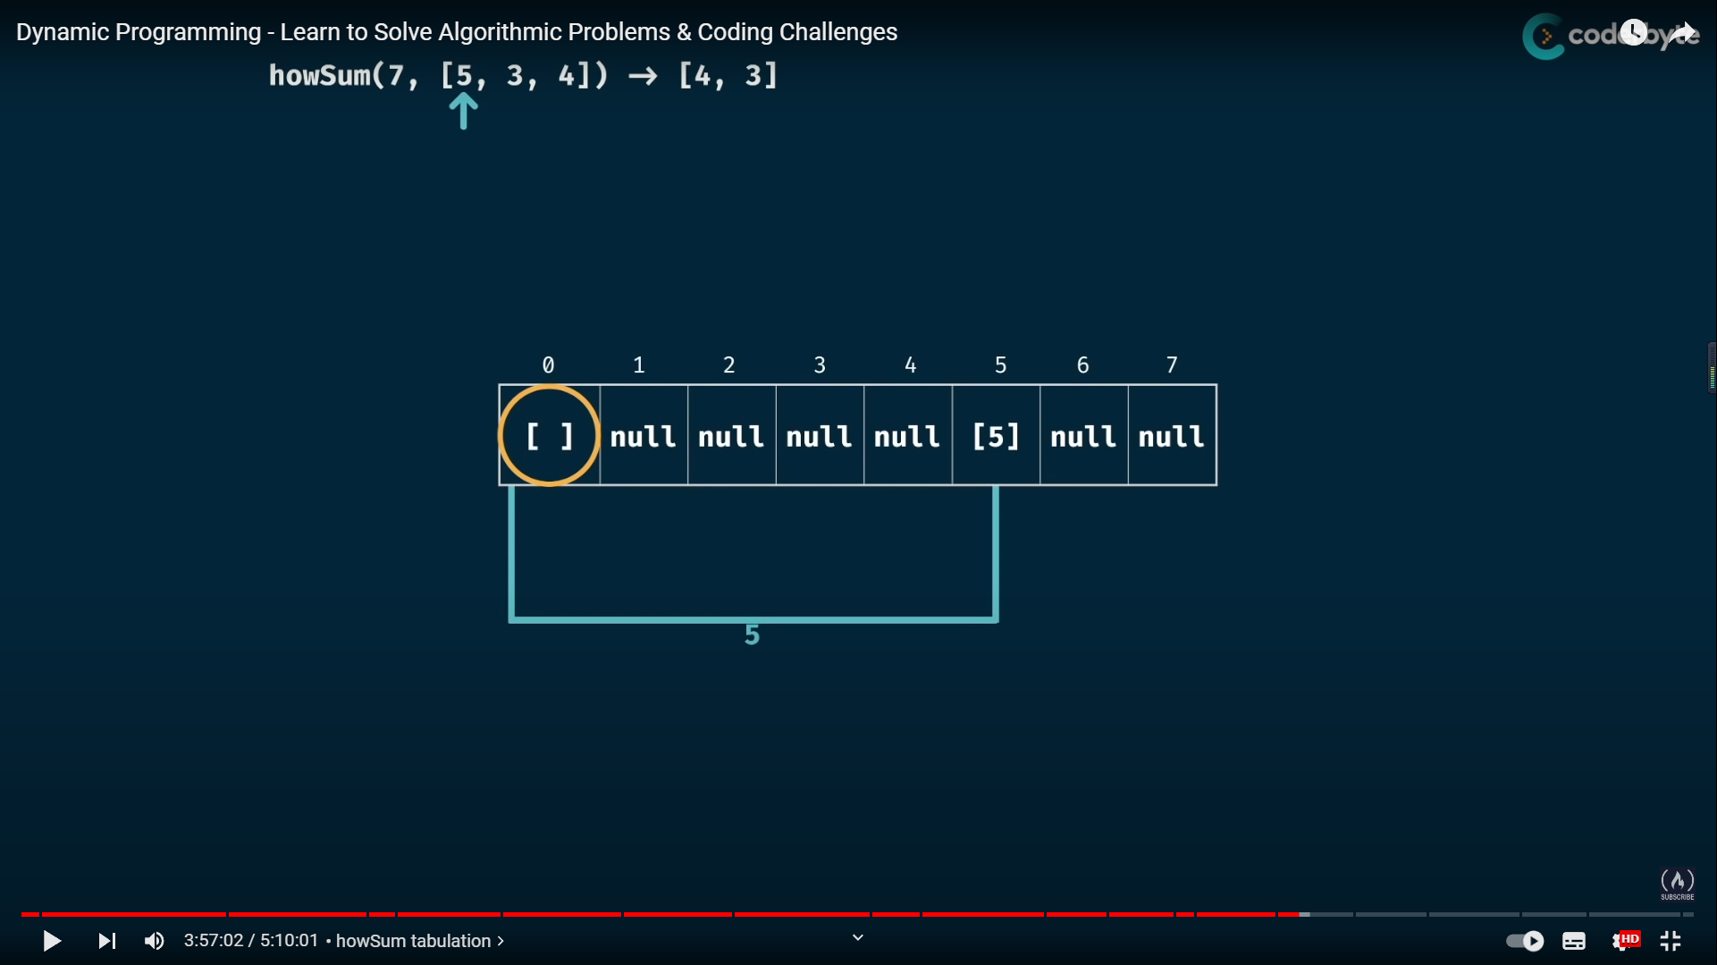

Fig. 17 How-Sum Tabulation

The time complexity is $O(m^{2}n)$. Apart from the $mn$ times of iteration involved in the algorithm, each iteration may contain the process of copying a previous returned list (because there are multiple lists involved here, we will use “returned list” to represent lists such as $List\left[8\right]=[3, 5]$), while the list contains at most $m$ elements. Because each slot of the list may contain a non-empty returned list and the returned list can be at most $m$-element long (when the returned list only contains a bunch of ones), the space complexity is $O(m^{2})$.

For the Best-Sum one, we only need to add an extra logic:

1. If this place is empty (null/none) when we try to fill in, then directly fill the new list in.
2. If this place is taken, then we compare the length of the existed content and the new content and choose the shorter one.

The complexities remain the same as the How-Sum design.

# Section VI Construct Tabulation

This section includes the notes for the rest of the three problems, Can-Construct, Count-Construct and All-Construct. What’s different is that we need to consider strings instead of numbers.

Similarly, the size of the Tabulation list is correlated with our inputs. Take the Can-Construct problem as an example, we can have the following list when target is “abcdef” and wordBank is “[“ab”, “abc”, “d”, “de”, “f”]”:

|  |  |  |  |  |  |  |
| --- | --- | --- | --- | --- | --- | --- |
| “” | “a” | “ab” | “abc” | “abcd” | “abcde” | “abcdef” |
| True | False | False | False | False | False | False |

And the exact reasons are:

1. Because we need to construct the target word in a certain order (in other words, we can’t have “abcd” when we only have “ac” and “db” in our hands), we can break the target string into seven possible scenarios.
2. Empty string is a basic scenario where we always return “True” because we don’t need anything to construct an empty string.

Again, we need to loop through every choice in the wordBank for each scenario to see what we can actually obtain with the wordBank. After completing the loop in $List\left[0\right]=""$, we have

|  |  |  |  |  |  |  |
| --- | --- | --- | --- | --- | --- | --- |
| “” | “a” | “ab” | “abc” | “abcd” | “abcde” | “abcdef” |
| True | False | True | True | False | False | False |

Then we switch to $List\left[1\right]="a"$. From the previous result, we observed that it is not possible to obtain “a” with the given wordBank, so we skip all the looping process because it will not affect the result list. Then for $List\left[2\right]="ab"$, because nothing in wordBank starts with “c”, the table will not change. For $List\left[3\right]="abc"$, we will change the result list to the following one because $"abc"+"d"="abcd"$ and $"abc"+"de"="abcde"$:

|  |  |  |  |  |  |  |
| --- | --- | --- | --- | --- | --- | --- |
| “” | “a” | “ab” | “abc” | “abcd” | “abcde” | “abcdef” |
| True | False | True | True | True | True | False |

After doing the same process for every element in the list, we have

|  |  |  |  |  |  |  |
| --- | --- | --- | --- | --- | --- | --- |
| “” | “a” | “ab” | “abc” | “abcd” | “abcde” | “abcdef” |
| True | False | True | True | True | True | True |

Once we understand this designing concept for strings, the algorithm designs for some similar topics can be carried out with the same structure, while the result values vary. For Count-Construct, the expected outcome is the number of possible ways. Hence, we initialise the list as

|  |  |  |  |  |  |  |
| --- | --- | --- | --- | --- | --- | --- |
| “” | “a” | “ab” | “abc” | “abcd” | “abcde” | “abcdef” |
| 1 | 0 | 0 | 0 | 0 | 0 | 0 |

While looping, suppose we are looping under the basic condition of $list[1]$ and the current choice from wordBank is $j$ ( $j$ is a string) and we have $list\left[1\right]+j=list[1+len(j)]$, then we have $list\left[1+len(j)\right]+=list\left[1\right]$.

For All-Construct, the expected outcome is an array of arrays, then we need to initialise the list as

|  |  |  |  |  |  |  |
| --- | --- | --- | --- | --- | --- | --- |
| “” | “a” | “ab” | “abc” | “abcd” | “abcde” | “abcdef” |
| [[]] | None | None | None | None | None | None |

When we have $list\left[1\right]+j=list[1+len(j)]$, we need to first have a temporary variable $temp$ that satisfies $temp[k]=list\left[1\right]\left[k\right]+j$, where $temp[k]$ is the $k$ th element of $temp$. And then add $temp$ to $list[1+len(j)]$.

Although the DP-based process can help us save more time and space, it might still crash while facing complex issues like All-Sum and All-Construct because the problems demand us to return **all** the answers, which is equivalent to checking all possible scenarios, leading to exponential time complexity.

# Section VII Conclusions

Some tips for the design of DP algorithms:

1. Draw a basic algorithm tree first (be sure that your example covers multiple scenarios)
2. Think what tasks/processes are overlapped when we implement the recursive design
3. Settle the basic scenarios (those that directly result in an input)
4. Think recursively for Memoisation and iteratively for Tabulation

And the course is finished.